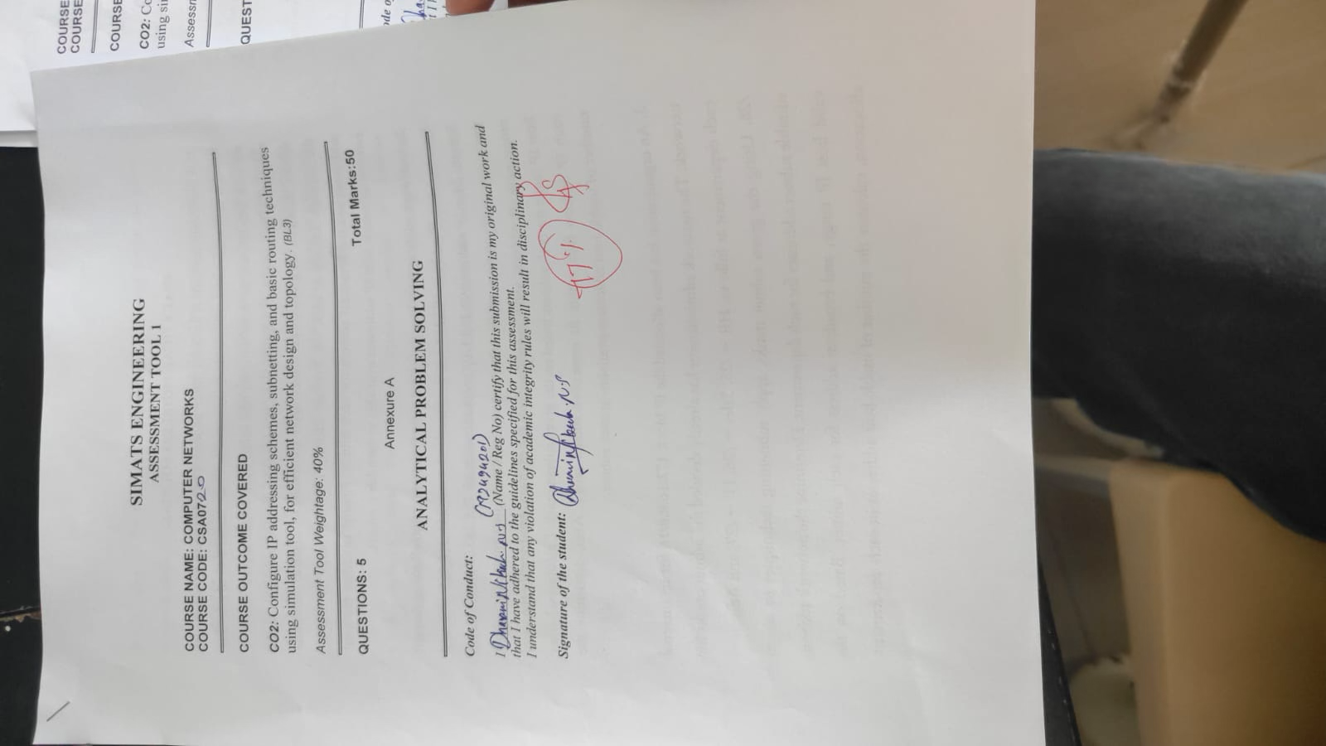
Annexure A

ANALYTICAL PROBLEM SOLVING
- A university network is assigned the IP address block 192.168.20.0/24 for its internal communication. The network administrator has decided to divide this network into subnets for three different labs using fixed subnet masks. Lab A is assigned a /26 subnet, Lab B is assigned a /27 subnet, and Lab C is assigned a /28 subnet. Based on the given subnet masks, apply subnetting concepts to determine the network address of each lab. Further, identify the valid range of host IP addresses and the broadcast address for each subnet. Finally, calculate the total number of usable host IP addresses available in each lab’s subnet.

- A network administrator has configured two systems with the following details: System 1 has IP address 192.168.1.130 with subnet mask 255.255.255.192, and System 2 has IP address 192.168.1.190 with subnet mask 255.255.255.192. Using the given configuration, apply subnetting techniques to determine the subnet range, network address, and broadcast address for each system. Identify the valid host IP range for both subnets based on the given subnet mask. Calculate whether each IP address falls within its respective subnet range. Also, determine the number of usable host addresses available in each subnet.

- An organization has been allocated the IP block 172.16.0.0/16 for its internal network. The network administrator has already decided the subnet masks for each department as follows: HR → /25, Sales → /26, IT → /27, and Admin →
/28. Using the given subnet masks, apply subnetting techniques to assign suitable subnet addresses for each department. Determine the network address, valid host IP range, and broadcast address for each subnet. Based on the allocation, calculate the number of usable host addresses in each department.
Finally, identify the remaining unused IP address range within the given network block.
- A company uses the IP address 172.16.10.0/24 and has implemented subnetting
using a /27 subnet mask for its internal departments. Using the given subnet mask, apply subnetting techniques to calculate the total number of subnets created and the number of usable hosts per subnet. Determine the subnet to which the IP address 172.16.10.78 belongs. Identify the network address and broadcast address for that subnet. Also, determine whether the IP address 172.16.10.95 falls within the same subnet range based on the given configuration.

- A network uses the Internet Protocol version 6 address 2001:0db8:0000:0000:0000:ff00:0042:8329. Apply IPv6 addressing rules to compress the given address into its shortest form and then expand the compressed address back to its full notation. Using a prefix length of /64, determine the network prefix of the given address. Also, calculate the total number of possible host addresses available within this network based on the given prefix length.

Q1: University Network Subnetting

1. Problem Understanding
A university has been assigned the IPv4 network: 192.168.20.0/24
The administrator wants to divide this network among three laboratories using different subnet sizes:
- Lab A → /26
- Lab B → /27
- Lab C → /28
We need to determine:
- Network address
- Valid host IP range
- Broadcast address
- Number of usable host addresses

2. Method Selection
For an IPv4 subnet with prefix /n:
Number of host bits = 32 − n
Total addresses = 2^(host bits)
Usable hosts = 2^(host bits) − 2
The subtraction of 2 accounts for the network address and broadcast address.
The block size can also be calculated as:
Block Size = 256 − subnet-mask value in the changing octet

3. Solution Process

Lab A – /26
Subnet mask: 255.255.255.192
Block size: 256 − 192 = 64
Therefore, the first subnet is:
- Network Address = 192.168.20.0
- First Host = 192.168.20.1
- Last Host = 192.168.20.62
- Broadcast = 192.168.20.63
Usable hosts:
2^(32−26) − 2
= 2⁶ − 2
= 62 hosts

Lab B – /27
The next available address is 192.168.20.64.
Subnet mask:
255.255.255.224
Block size:
256 − 224 = 32
Therefore:
- Network Address = 192.168.20.64
- First Host = 192.168.20.65
- Last Host = 192.168.20.94
- Broadcast = 192.168.20.95
Usable hosts:
2⁵ − 2 = 30 hosts

Lab C – /28
The next available address is 192.168.20.96.
Subnet mask: 255.255.255.240
Block size: 256 − 240 = 16
Therefore:
- Network Address = 192.168.20.96
- First Host = 192.168.20.97
- Last Host = 192.168.20.110
- Broadcast = 192.168.20.111
Usable hosts:
2⁴ − 2 = 14 hosts

4. Final Results
 | Prefix | Network Address | Valid Host Range | Broadcast | Usable Hosts
A | /26 | 192.168.20.0 | .1 – .62 | .63 | 62
B | /27 | 192.168.20.64 | .65 – .94 | .95 | 30
C | /28 | 192.168.20.96 | .97 – .110 | .111 | 14

5. Interpretation
The administrator can allocate different-sized subnets according to the requirements of each laboratory. Lab A receives the largest subnet with 62 usable hosts, while Lab C receives the smallest with 14 usable hosts. This avoids assigning the entire /24 network to one laboratory and improves IP address utilization.

Q2: Identifying Subnets of Two Systems

1. Problem Understanding
Given:
System 1: 192.168.1.130
System 2: 192.168.1.190
Subnet mask:
255.255.255.192 = /26
We need to determine:
- Subnet range
- Network address
- Broadcast address
- Valid host range
- Whether each IP is valid
- Number of usable hosts
- Whether both systems are in the same subnet

2. Method Selection
For /26:
Host bits:
32 − 26 = 6
Usable hosts:
2⁶ − 2 = 62
Subnet mask:
255.255.255.192
Block size:
256 − 192 = 64
Thus, the subnet boundaries are:
- 0
- 64
- 128
- 192

3. Solution Process
Both IP addresses fall between 128 and 191.
Therefore, both belong to: 192.168.1.128/26

Subnet Details
- Network Address = 192.168.1.128
- First Host = 192.168.1.129
- Last Host = 192.168.1.190
- Broadcast = 192.168.1.191

System 1
IP: 192.168.1.130
Since: 129 ≤ 130 ≤ 190
the IP is a valid host address.

System 2
IP: 192.168.1.190
Since: 129 ≤ 190 ≤ 190
the IP is also a valid host address.

4. Final Results
Parameter | System 1 | System 2
IP Address | 192.168.1.130 | 192.168.1.190
Network | 192.168.1.128/26 | 192.168.1.128/26
Host Range | .129 – .190 | .129 – .190
Broadcast | .191 | .191
Valid Host? | Yes | Yes
Usable hosts = 62

5. Interpretation
Both systems belong to the same /26 subnet and can communicate directly at the local network layer without requiring a router for communication between them, assuming normal LAN configuration.

Q3: Departmental Subnet Allocation

1. Problem Understanding
The organization has: 172.16.0.0/16
Departments require:
- HR → /25
- Sales → /26
- IT → /27
- Admin → /28
We must determine the subnet address, valid host range, broadcast address, usable hosts, and remaining address space.

2. Method Selection
The departments are assigned different prefix lengths. Therefore, the allocation follows a variable-sized subnet allocation approach, where each department receives the specified subnet size.
Usable hosts:
2^(32−prefix) − 2

3. Solution Process

HR – /25
Host bits: 32 − 25 = 7
Usable hosts: 2⁷ − 2 = 126
Network: 172.16.0.0/25
- Network = 172.16.0.0
- Hosts = 172.16.0.1 – 172.16.0.126
- Broadcast = 172.16.0.127

Sales – /26
Next address: 172.16.0.128
Host bits: 32 − 26 = 6
Usable hosts: 2⁶ − 2 = 62
Therefore:
- Network = 172.16.0.128
- Hosts = 172.16.0.129 – 172.16.0.190
- Broadcast = 172.16.0.191

IT – /27
Next address: 172.16.0.192
Host bits: 32 − 27 = 5
Usable hosts: 2⁵ − 2 = 30
Therefore:
- Network = 172.16.0.192
- Hosts = 172.16.0.193 – 172.16.0.222
- Broadcast = 172.16.0.223

Admin – /28
Next address: 172.16.0.224
Host bits: 32 − 28 = 4
Usable hosts: 2⁴ − 2 = 14
Therefore:
- Network = 172.16.0.224
- Hosts = 172.16.0.225 – 172.16.0.238
- Broadcast = 172.16.0.239

4. Final Results
Department | Prefix | Network | Host Range | Broadcast | Usable Hosts
HR | /25 | 172.16.0.0 | .1 – .126 | .127 | 126
Sales | /26 | 172.16.0.128 | .129 – .190 | .191 | 62
IT | /27 | 172.16.0.192 | .193 – .222 | .223 | 30
Admin | /28 | 172.16.0.224 | .225 – .238 | .239 | 14

Remaining Address Space
Original /16 range: 172.16.0.0 – 172.16.255.255
Allocated up to: 172.16.0.239
Therefore, the remaining unused range is:
172.16.0.240 – 172.16.255.255

5. Interpretation
The allocation efficiently assigns larger subnets to departments requiring more hosts and smaller subnets to departments requiring fewer hosts. A large portion of the original /16 network remains available for future departments or network expansion.

Q4: Subnetting 172.16.10.0/24 Using /27

1. Problem Understanding
Given: 172.16.10.0/24
New subnet mask: /27
We need to calculate:
- Number of subnets
- Usable hosts per subnet
- Subnet containing 172.16.10.78
- Network address
- Broadcast address
- Whether 172.16.10.95 belongs to the same subnet

2. Method Selection
Original prefix: /24
New prefix: /27
Number of borrowed bits: 27 − 24 = 3
Number of subnets: 2³ = 8
Host bits: 32 − 27 = 5
Usable hosts: 2⁵ − 2 = 30

3. Solution Process
Subnet mask: 255.255.255.224
Block size: 256 − 224 = 32
Subnets occur at: 0, 32, 64, 96, 128, 160, 192, 224
The IP 172.16.10.78 lies between: 64 and 95
Therefore, it belongs to: 172.16.10.64/27
Details:
- Network = 172.16.10.64
- First Host = 172.16.10.65
- Last Host = 172.16.10.94
- Broadcast = 172.16.10.95

Checking 172.16.10.95
The address 172.16.10.95 is the broadcast address.
Therefore, it is within the subnet's address range but cannot be assigned to a host.

4. Final Results
- Number of subnets = 8
- Usable hosts/subnet = 30
- IP 172.16.10.78 → 172.16.10.64/27
- Network = 172.16.10.64
- Host range = 172.16.10.65 – 172.16.10.94
- Broadcast = 172.16.10.95
- 172.16.10.95 → Same subnet, but broadcast address

5. Interpretation
Subnetting the /24 network into /27 networks creates 8 smaller networks, each capable of supporting 30 usable hosts. The address .78 is a valid host, whereas .95 is reserved for broadcasting within that subnet.

Q5: IPv6 Address Compression and /64 Prefix

1. Problem Understanding
Given IPv6 address:
2001:0db8:0000:0000:0000:ff00:0042:8329
Required:
- Compress the IPv6 address
- Expand it back
- Determine the /64 network prefix
- Calculate the number of possible addresses

2. Method Selection
IPv6 provides two important compression rules:
- Leading zeros in each hexadecimal block can be removed.
- One consecutive sequence of zero blocks can be replaced by ::.
An IPv6 address contains 128 bits.
For /64: 128 − 64 = 64 host bits
Therefore:
Number of possible addresses = 2⁶⁴

3. Solution Process
Original: 2001:0db8:0000:0000:0000:ff00:0042:8329
Remove leading zeros: 2001:db8:0:0:0:ff00:42:8329
Compress consecutive zero blocks:

Compressed form
2001:db8::ff00:42:8329

Expanded form
2001:0db8:0000:0000:0000:ff00:0042:8329

/64 Network Prefix
The first four groups represent the first 64 bits:
2001:0db8:0000:0000
Therefore:

Network Prefix = 2001:db8:0:0::/64

Number of Possible Addresses
Host bits: 128 − 64 = 64
Therefore: 2⁶⁴ = 18,446,744,073,709,551,616
possible IPv6 addresses.

4. Final Results
Parameter | Answer
Original IPv6 | 2001:0db8:0000:0000:0000:ff00:0042:8329
Compressed | 2001:db8::ff00:42:8329
Expanded | 2001:0db8:0000:0000:0000:ff00:0042:8329
Prefix | /64
Network Prefix | 2001:db8:0:0::/64
Host Bits | 64
Possible Addresses | 2⁶⁴ = 18,446,744,073,709,551,616

5. Interpretation
A /64 IPv6 network provides an extremely large address space of approximately 18.4 quintillion addresses. The first 64 bits identify the network, while the remaining 64 bits are available for interface addressing. IPv6 does not use the IPv4 concept of a broadcast address.

